**Predicting whether breast cancer is benign or malignant using Random Forest**

*Deliverables:*

1. The model that I have created I have created has an AUC of 0.9932.
2. Variables that influence in prediction whether the cancer is malignant or benign are given from the least to greatest:

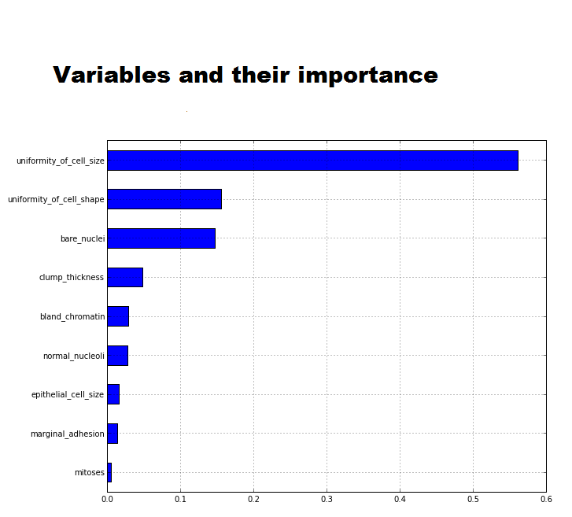

From the above bar graph, we can infer the following:

1. Mitoses – It is the least deciding factor whether the cancer is benign or malignant.
2. Uniformity of cell size, Uniformity of Cell Shape and Bare Nuclei are the most important factors in deciding if the cancer is benign or not. Uniformity of cell size determines whether the cancerous cells are expanding/have expanded. This helps understand whether the cancer is malignant or benign.
3. Also, in this prediction model, I have eliminated Id number since it does not help in prediction.